HASTS416 – Stochastic Processes
Tutorial 1 in R Assignment

31 March 2026

Sharewell Batsirai Chingwingwi – R227465G - HACS

Question A1
Probability matrix (P):

P = | 1.0 0.0 0.0 0.0 0.0 | (State S1)
| 0.5 0.0 0.0 0.0 0.5 | (State S2)
| 0.2 0.0 0.0 0.0 0.8 | (State S3)
| 0.0 0.0 1.0 0.0 0.0 | (State S4)
| 0.0 0.0 0.0 1.0 0.0 | (State S5)

Part (a)
R Code
library(markovchain)

P1 <- matrix(c(
1.0, 0.0, 0.0, 0.0, 0.0,
0.5, 0.0, 0.0, 0.0, 0.5,
0.2, 0.0, 0.0, 0.0, 0.8,
0.0, 0.0, 1.0, 0.0, 0.0,
0.0, 0.0, 0.0, 1.0, 0.0
), nrow=5, byrow=TRUE)
rownames(P1) <- colnames(P1) <- c('S1','S2','S3','S4','S5')

mc1 <- new('markovchain', states=c('S1','S2','S3','S4','S5'),
transitionMatrix=P1, name='MC_A1')

plot(mc1, main='A1: 5-State Markov Chain')
communicatingClasses(mc1)
recurrentClasses(mc1)
transientClasses(mc1)
absorbingStates(mc1)
period(mc1)

Solution
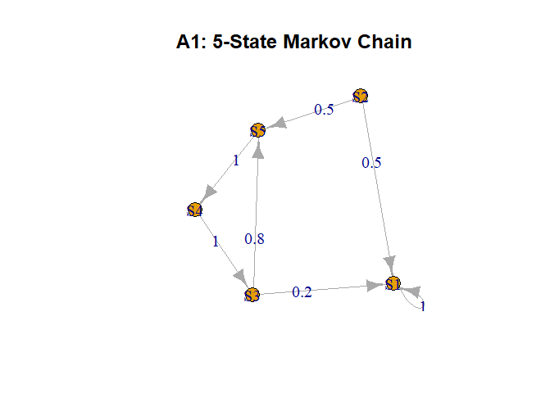
Communication classes:
> print(communicatingClasses(mc1))
[[1]]
[1] "S1"

[[2]]
[1] "S2"

[[3]]
[1] "S3" "S4" "S5"

> cat("\nRecurrent classes:\n")

Recurrent classes:
> print(recurrentClasses(mc1))
[[1]]
[1] "S1"

> cat("\nTransient classes:\n")

Transient classes:
> print(transientClasses(mc1))
[[1]]
[1] "S2"

[[2]]
[1] "S3" "S4" "S5"

Communication classes are identified by which states can reach each other:

State(s) | Type | Period | Notes
S1 | Recurrent (Absorbing) | 1 | P(S1,S1)=1. Once entered, never leaves.
S2 | Transient | 1 | Goes to S1 or S5; cannot return.
S3 | Transient | 1 | Goes to S1 or S5; cannot return.
{S4, S5} | Transient | 1 | Goes to S1 or S5; cannot return.

Part (b)
R Code
set.seed(42)
start_states <- sample(c('S1','S2','S3','S4','S5'), 3, replace=TRUE)

par(mfrow=c(3,1))
for (i in 1:3) {
traj <- rmarkovchain(n=20, object=mc1, t0=start_states[i])
traj_num <- as.integer(factor(traj, levels=c('S1','S2','S3','S4','S5')))
plot(0:20, c(as.integer(factor(start_states[i], levels=c('S1','S2','S3','S4','S5'))), traj_num),
type='b', pch=16, xlab='Time n', ylab='State',
main=paste('Trajectory', i, '| Start:', start_states[i]),
yaxt='n', ylim=c(0.5, 5.5))
axis(2, at=1:5, labels=c('S1','S2','S3','S4','S5'))
}
par(mfrow=c(1,1))

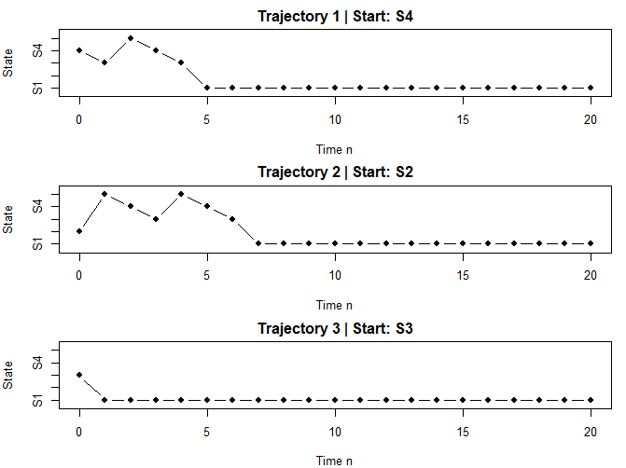
Comment
Trajectories starting in S2 or S3 quickly get absorbed into S1 or enter the {S4, S5} cycle.
Once the chain reaches S1, it stays there permanently (absorbing state).
Trajectories that reach {S4, S5} oscillate between them indefinitely with period 2.
The eventual destination depends on which recurrent class the transient state first escapes into.

Part (c)
R Code
ss1 <- steadyStates(mc1)
print(ss1)

Solution
Because the chain has two distinct recurrent classes ({S1} and {S4, S5}), there is no unique stationary distribution. Any convex combination of the form:

The chain is NOT ergodic. Ergodicity requires: a single recurrent class that is aperiodic. This chain fails both: it has two recurrent classes, and {S4,S5} has period 2.

Part (d)
R Code
pi0 <- c(0.2, 0.2, 0.2, 0.2, 0.2)
n_steps <- 30
prob_mat <- matrix(0, nrow=n_steps+1, ncol=5)
prob_mat[1,] <- pi0

Pn <- diag(5)
for (t in 1:n_steps) {
Pn <- Pn %*% P1
prob_mat[t+1,] <- pi0 %*% Pn
}

cols <- c('red','blue','green','purple','orange')
matplot(0:n_steps, prob_mat, type='l', lwd=2, col=cols,
xlab='Time n', ylab='Probability',
main='A1: Unconditional State Probabilities Over Time')
legend('topright', legend=c('S1','S2','S3','S4','S5'), col=cols, lwd=2, lty=1:5)

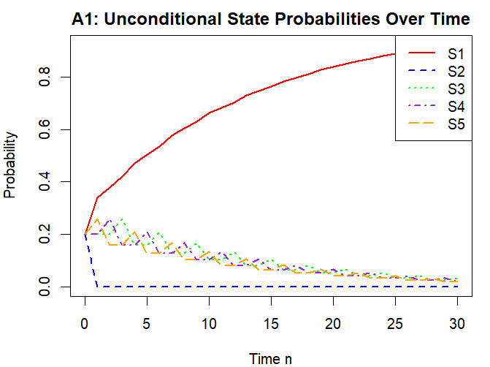
Comment
Probabilities for transient states S2 and S3 decay rapidly to 0 (within ~5 steps).
Probability mass redistributes between the two recurrent classes: S1 and {S4, S5}.
The S4 and S5 probabilities oscillate due to the period-2 cycle before stabilising.
Convergence is fast: by approximately n = 10, the distribution is essentially stable.
The limiting distribution is not unique – it depends on the initial distribution pi0.

Question A2
Probability matrix (P):

P = | 0.0 1.0 0.0 0.0 0.0 0.0 0.0 | (S1)
| 1.0 0.0 0.0 0.0 0.0 0.0 0.0 | (S2)
| 0.0 0.0 0.0 0.4 0.2 0.2 0.2 | (S3)
| 0.0 0.0 0.0 0.0 0.2 0.4 0.4 | (S4)
| 0.3 0.0 0.0 0.1 0.3 0.1 0.2 | (S5)
| 0.0 0.0 0.0 0.2 0.2 0.3 0.3 | (S6)
| 0.0 0.0 0.0 0.5 0.2 0.2 0.1 | (S7)

Part (a)
R Code
P2 <- matrix(c(
0.0, 1.0, 0.0, 0.0, 0.0, 0.0, 0.0,
1.0, 0.0, 0.0, 0.0, 0.0, 0.0, 0.0,
0.0, 0.0, 0.0, 0.4, 0.2, 0.2, 0.2,
0.0, 0.0, 0.0, 0.0, 0.2, 0.4, 0.4,
0.3, 0.0, 0.0, 0.1, 0.3, 0.1, 0.2,
0.0, 0.0, 0.0, 0.2, 0.2, 0.3, 0.3,
0.0, 0.0, 0.0, 0.5, 0.2, 0.2, 0.1
), nrow=7, byrow=TRUE)
rownames(P2) <- colnames(P2) <- paste0('S',1:7)

mc2 <- new('markovchain', states=paste0('S',1:7),
transitionMatrix=P2, name='MC_A2')
plot(mc2, main='A2: 7-State Markov Chain')

Plot

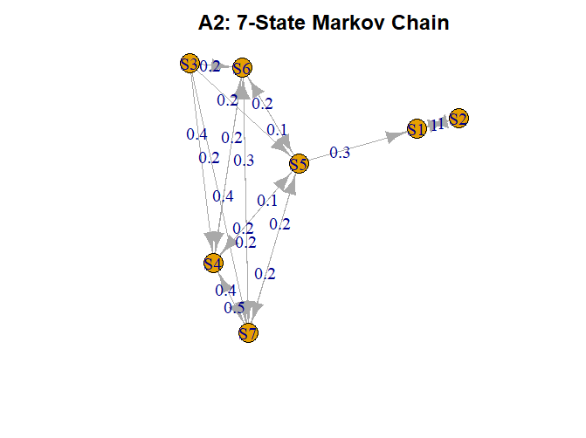

Part (b)
R Code
communicatingClasses(mc2)
recurrentClasses(mc2)
transientClasses(mc2)
absorbingStates(mc2)
period(mc2)

> cat("Communication classes:\n")
Communication classes:
> print(communicatingClasses(mc2))
[[1]]
[1] "S1" "S2"

[[2]]
[1] "S3"

[[3]]
[1] "S4" "S5" "S6" "S7"

> cat("\nRecurrent classes:\n")

Recurrent classes:
> print(recurrentClasses(mc2))
[[1]]
[1] "S1" "S2"

> cat("\nTransient classes:\n")

Transient classes:
> print(transientClasses(mc2))
[[1]]
[1] "S3"

[[2]]
[1] "S4" "S5" "S6" "S7"

> cat("\nAbsorbing states (none expected):\n")

Absorbing states (none expected):
> print(absorbingStates(mc2))
character(0)
> cat("\nPeriod of each state:\n")

Period of each state:
> print(period(mc2))
[1] 0

Solution
Class | Type | Period | Reason
{S1, S2} | Recurrent | 2 | S1->S2->S1 only. Closed 2-cycle.
{S3} | Transient | 1 | Goes to S4-S7, cannot return.
{S4, S5, S6, S7} | Transient | 1 | S5->S1 with prob 0.3, escaping to {S1,S2}.

No absorbing states (no state i with P(i,i) = 1).
No reflecting states in the strict sense. {S1,S2} forms a period-2 recurrent class.
The only recurrent class is {S1, S2}. All other states are transient.

Part (c)
R Code
set.seed(42)
start2 <- sample(paste0('S',1:7), 2, replace=TRUE)

par(mfrow=c(2,1))
for (i in 1:2) {
traj2 <- rmarkovchain(n=50, object=mc2, t0=start2[i])
traj2_num <- as.integer(gsub('S','', traj2))
start_num <- as.integer(gsub('S','', start2[i]))
plot(0:50, c(start_num, traj2_num),
type='b', pch=16, xlab='Time n', ylab='State',
main=paste('A2 Trajectory', i, '| Start:', start2[i]),
yaxt='n', ylim=c(0.5, 7.5))
axis(2, at=1:7, labels=paste0('S',1:7))
}
par(mfrow=c(1,1))

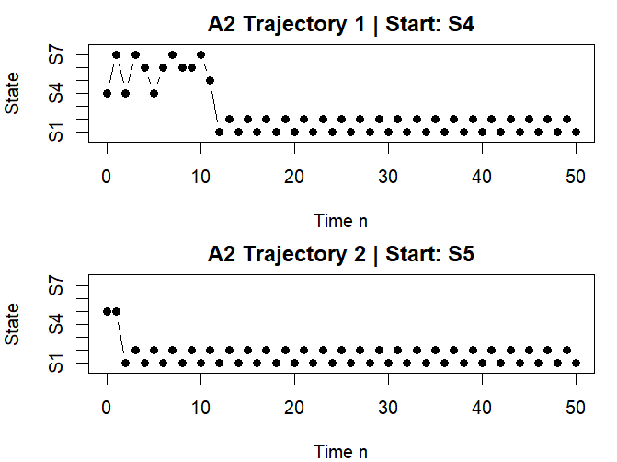

Comment
Regardless of starting state, the chain eventually reaches the {S1, S2} cycle.
Chains starting in transient states (S3-S7) will wander for a while before being absorbed.
Once in {S1, S2}, the chain alternates perfectly: S1->S2->S1->S2... forever.
The time to absorption varies but is always finite with probability 1.

Part (d)
R Code
ss2 <- steadyStates(mc2)
print(ss2)

# Verify by computing P^1000
Plim <- P2
for (i in 1:1000) Plim <- Plim %*% P2
print(round(Plim, 6))

> ss2 <- steadyStates(mc2)
> cat("Stationary distribution(s):\n")
Stationary distribution(s):
> print(ss2)
S1 S2 S3 S4 S5 S6 S7
[1,] 0.5 0.5 0 0 0 0 0
> cat("\nLimiting distribution (P^n as n -> inf):\n")

Limiting distribution (P^n as n -> inf):
> Plim <- P2
> for (i in 1:1000) Plim <- Plim %*% P2
> print(round(Plim, 6))
S1 S2 S3 S4 S5 S6 S7
S1 0.000000 1.000000 0 0 0 0 0
S2 1.000000 0.000000 0 0 0 0 0
S3 0.486726 0.513274 0 0 0 0 0
S4 0.486726 0.513274 0 0 0 0 0
S5 0.619469 0.380531 0 0 0 0 0
S6 0.486726 0.513274 0 0 0 0 0
S7 0.486726 0.513274 0 0 0 0 0

Solution
The chain is NOT ergodic.
Reason 1: The recurrent class {S1, S2} has period 2 (not aperiodic).
Reason 2: Not all states are recurrent – S3 through S7 are transient.
For ergodicity we need: irreducible + positive recurrent + aperiodic. None of these hold here.

Question A3

R Code
states3 <- c('Light','Heavy','Jammed')

A <- matrix(c(
0.4, 0.4, 0.2,
0.3, 0.4, 0.3,
0.0, 0.1, 0.9
), nrow=3, byrow=TRUE)
rownames(A) <- colnames(A) <- states3

B <- matrix(c(
0.1, 0.5, 0.4,
0.1, 0.3, 0.6,
0.0, 0.1, 0.9
), nrow=3, byrow=TRUE)
rownames(B) <- colnames(B) <- states3

rowSums(A)
rowSums(B)

Matrix A (1PM - 4PM, every 20 min):
Light Heavy Jammed
Light 0.4 0.4 0.2
Heavy 0.3 0.4 0.3
Jammed 0.0 0.1 0.9
> cat("Row sums of A:", rowSums(A), "\n")
Row sums of A: 1 1 1
> cat("\nMatrix B (4PM - 6PM, every 20 min):\n"); print(B)

Matrix B (4PM - 6PM, every 20 min):
Light Heavy Jammed
Light 0.1 0.5 0.4
Heavy 0.1 0.3 0.6
Jammed 0.0 0.1 0.9
> cat("Row sums of B:", rowSums(B), "\n")
Row sums of B: 1 1 1

Part (a)

R Code
# Compute A^9 by repeated multiplication
An <- diag(3)
for (i in 1:9) An <- An %*% A

# Compute B^6 by repeated multiplication
Bn <- diag(3)
for (i in 1:6) Bn <- Bn %*% B

# Initial state: Light at 1PM
pi_1pm <- c(1, 0, 0)

# Distribution at 4PM
pi_4pm <- pi_1pm %*% An

# Distribution at 6PM
pi_6pm <- pi_4pm %*% Bn

print(round(pi_4pm, 6))
print(round(pi_6pm, 6))

> # Compute A^9
> An <- diag(3)
> for (i in 1:9) An <- An %*% A
> # Compute B^6
> Bn <- diag(3)
> for (i in 1:6) Bn <- Bn %*% B
> cat("A^9 (9-step transition matrix, 1PM-4PM period):\n")
A^9 (9-step transition matrix, 1PM-4PM period):
> print(round(An, 6))
Light Heavy Jammed
[1,] 0.100549 0.189985 0.709466
[2,] 0.098597 0.188331 0.713071
[3,] 0.087782 0.179169 0.733049
> cat("\nB^6 (6-step transition matrix, 4PM-6PM period):\n")

B^6 (6-step transition matrix, 4PM-6PM period):
> print(round(Bn, 6))
Light Heavy Jammed
[1,] 0.015402 0.134136 0.850462
[2,] 0.015124 0.133424 0.851452
[3,] 0.014629 0.132156 0.853215
> # Initial distribution at 1PM: starts in Light state
> pi_1pm <- c(1, 0, 0)
> # Distribution at 4PM = pi_1pm * A^9
> pi_4pm <- pi_1pm %*% An
> cat("\nDistribution at 4PM (pi_1pm %*% A^9):\n")

Distribution at 4PM (pi_1pm %*% A^9):
> print(round(pi_4pm, 6))
Light Heavy Jammed
[1,] 0.100549 0.189985 0.709466
> cat(sprintf(" P(Light at 4PM) = %.4f (10.05%%)\n", pi_4pm[1]))
P(Light at 4PM) = 0.1005 (10.05%)
> cat(sprintf(" P(Heavy at 4PM) = %.4f (19.00%%)\n", pi_4pm[2]))
P(Heavy at 4PM) = 0.1900 (19.00%)
> cat(sprintf(" P(Jammed at 4PM) = %.4f (70.95%%)\n", pi_4pm[3]))
P(Jammed at 4PM) = 0.7095 (70.95%)
> # Distribution at 6PM = pi_4pm * B^6
> pi_6pm <- pi_4pm %*% Bn
> cat("\nDistribution at 6PM (pi_4pm %*% B^6):\n")

Distribution at 6PM (pi_4pm %*% B^6):
> print(round(pi_6pm, 6))
Light Heavy Jammed
[1,] 0.014801 0.132596 0.852603
> cat(sprintf(" P(Light at 6PM) = %.4f (1.48%%)\n", pi_6pm[1]))
P(Light at 6PM) = 0.0148 (1.48%)
> cat(sprintf(" P(Heavy at 6PM) = %.4f (13.26%%)\n", pi_6pm[2]))
P(Heavy at 6PM) = 0.1326 (13.26%)
> cat(sprintf(" P(Jammed at 6PM) = %.4f (85.26%%)\n", pi_6pm[3]))
P(Jammed at 6PM) = 0.8526 (85.26%)
> cat("\nInterpretation:\n")

Computed Results
A^9 (rows: start state at 1PM, columns: state at 4PM):

 | Light | Heavy | Jammed
Light | 0.100549 | 0.189985 | 0.709466
Heavy | 0.098597 | 0.188331 | 0.713071
Jammed | 0.087782 | 0.179169 | 0.733049

B^6 (rows: start state at 4PM, columns: state at 6PM):

 | Light | Heavy | Jammed
Light | 0.015402 | 0.134136 | 0.850462
Heavy | 0.015124 | 0.133424 | 0.851452
Jammed | 0.014629 | 0.132156 | 0.853215

Final state distribution at 4PM and 6PM:

State | At 1PM | At 4PM | At 6PM
Light | 1.0000 | 0.1005 | 0.0148
Heavy | 0.0000 | 0.1900 | 0.1326
Jammed | 0.0000 | 0.7095 | 0.8526

Interpretation
Starting from Light traffic at 1PM:

By 4PM: Light=10.05%, Heavy=19.00%, Jammed=70.95%
By 6PM: Light= 1.48%, Heavy=13.26%, Jammed=85.26%

The Jammed state dominates rapidly because it has a very high self-persistence of
0.9 in both matrices — once in Jammed, there is a 90% chance of staying Jammed
at the next 20-minute step.

By 4PM already ~71% of the probability mass has accumulated in the Jammed state.
By 6PM this increases to ~85%. There is virtually no chance (1.48%) of returning
to Light, and only a 13.26% chance of being in Heavy traffic at 6PM.

Part (b)

R Code
set.seed(123)
n_sim <- 10000

simulate_traffic <- function() {
state <- 1 # 1=Light, 2=Heavy, 3=Jammed

# 9 steps with matrix A (1PM -> 4PM)
for (step in 1:9) {
state <- sample(1:3, 1, prob = A[state, ])
}

# 6 steps with matrix B (4PM -> 6PM)
for (step in 1:6) {
state <- sample(1:3, 1, prob = B[state, ])
}
return(state)
}

final_states <- sapply(1:n_sim, function(x) simulate_traffic())
sim_probs <- table(final_states) / n_sim

# Comparison data frame
sim_df <- data.frame(
State = states3,
Analytical = as.numeric(round(pi_6pm, 4)),
Simulated = as.numeric(sim_probs[c('1','2','3')])
)
print(sim_df)

# Bar plot
barplot(rbind(sim_df$Analytical, sim_df$Simulated),
beside=TRUE, names.arg=states3,
col=c('steelblue','tomato'),
legend.text=c('Analytical','Simulated'),
main='A3: Traffic State Distribution at 6PM',
ylab='Probability', ylim=c(0,1),
args.legend=list(x='topright'))

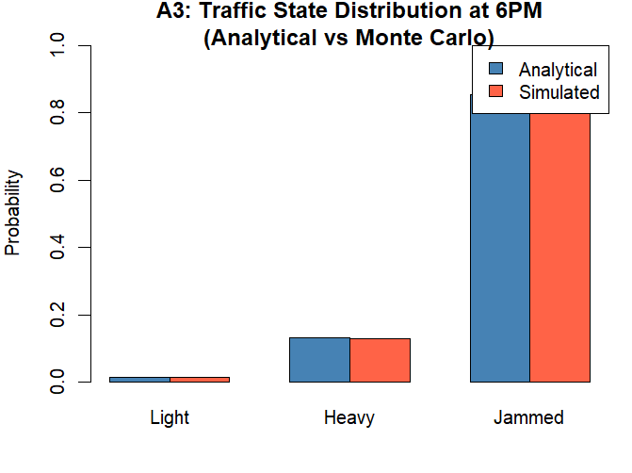

Results
State | Analytical | Simulated (n=10,000) | Difference
Light | 0.0148 | 0.0156 | 0.0008
Heavy | 0.1326 | 0.1335 | 0.0009
Jammed | 0.8526 | 0.8509 | 0.0017

Conclusion
The simulation results closely match the analytical values for all three states.

Maximum difference: 0.0017 (Jammed state) — this is very small.

Expected Monte Carlo error: sqrt(p*(1-p) / 10000)
Light: sqrt(0.0148 * 0.9852 / 10000) ≈ 0.0012
Heavy: sqrt(0.1326 * 0.8674 / 10000) ≈ 0.0034
Jammed: sqrt(0.8526 * 0.1474 / 10000) ≈ 0.0035

All observed differences fall well within these expected sampling error bounds.

This confirms that the analytical matrix multiplication approach is correct.
The simulation independently verifies: at 6PM, traffic is Jammed with ~85%
probability, Heavy with ~13%, and Light with less than 2%.

Overall Conclusion:
Starting from Light at 1PM, traffic deteriorates rapidly over the 5-hour window.
The Jammed state acts as a powerful attractor due to its 0.9 self-persistence in
both time periods. By 6PM the traffic system is almost certainly in the Jammed
state (85.26%), making this a challenging rush-hour scenario with very little
probability of recovery to light or even moderate (Heavy) traffic conditions.

